Appendix to Reuman and Cohen, Trophic links' length and slope in the Tuesday Lake food web with species’ body mass and numerical abundance
Figures A1-A4
Tables A1-A9
Additional Results
Matlab Code for Models
Figure A1: Estimate of the 1984 frequency distribution of numerical abundance in Tuesday Lake, using a kernel density estimator. Probability density function was obtained using the Matlab statistics toolbox function 'ksdensity', with a normal window of varying standard deviation ranging from 0.2 to 1.4, illustrated here with a window of width 0.6 on the l₁ scale. The dividing points between the groups of the N-grouping were the first two local minima to emerge in the density estimate as the window standard deviation was decreased. The N-grouping in 1986 and the M-grouping in both years were determined in the same way.
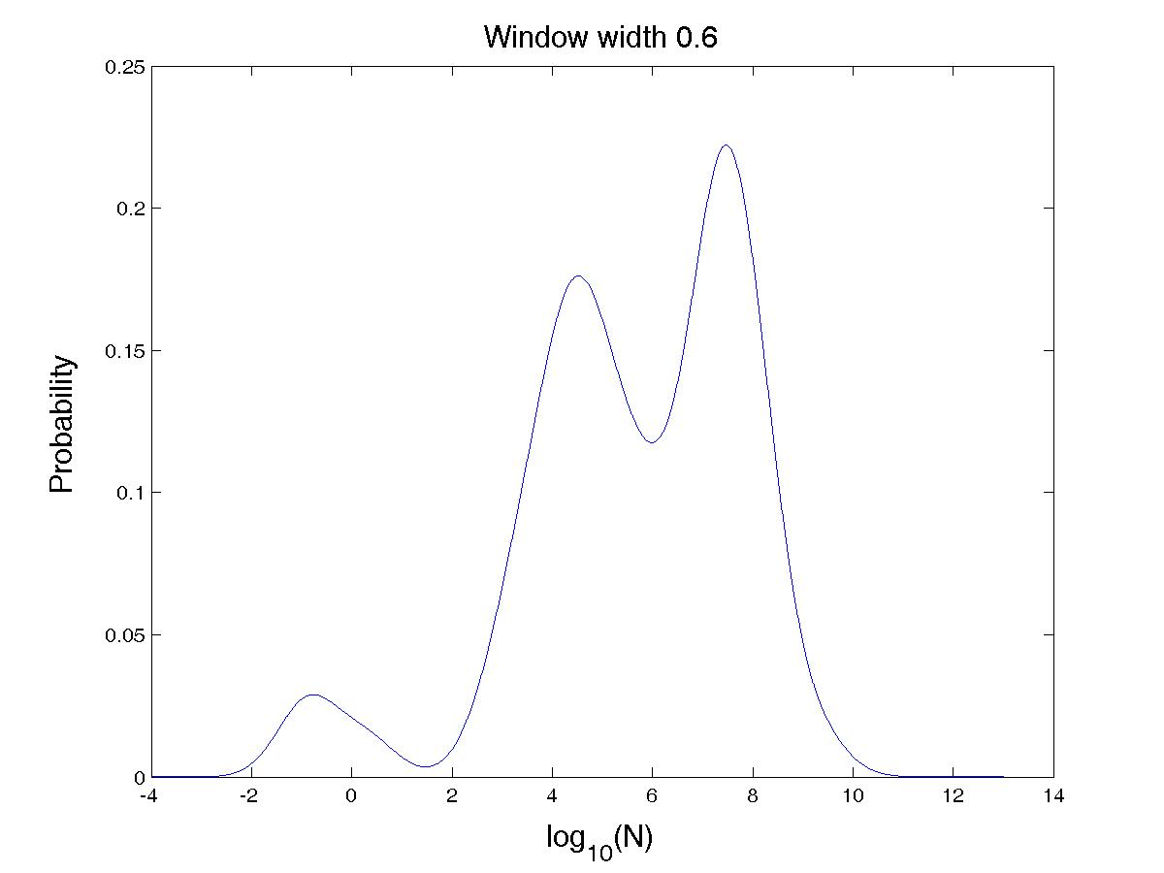
Figure A2: Predation matrices in (A) 1984 and (B) 1986. Each mark represents a link. The blocks in Appendix Table A9 are superimposed on the figures.
2A:
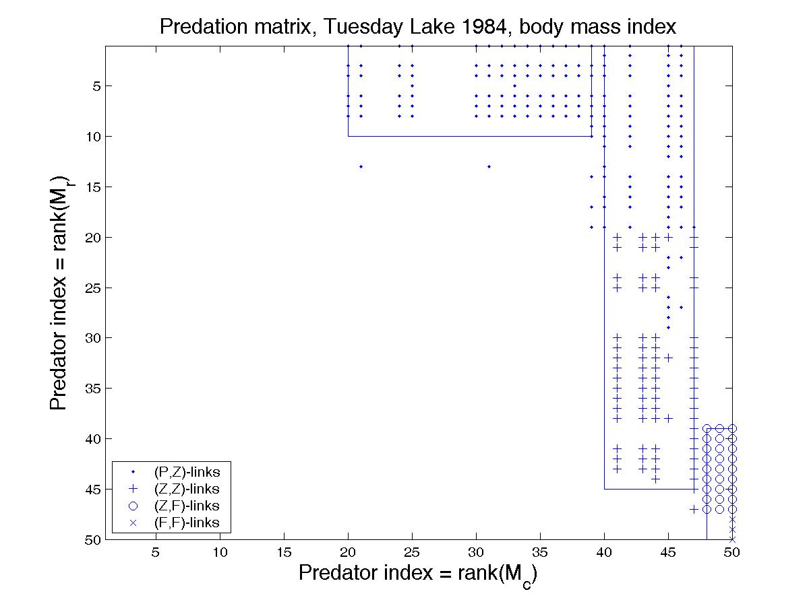
2B:
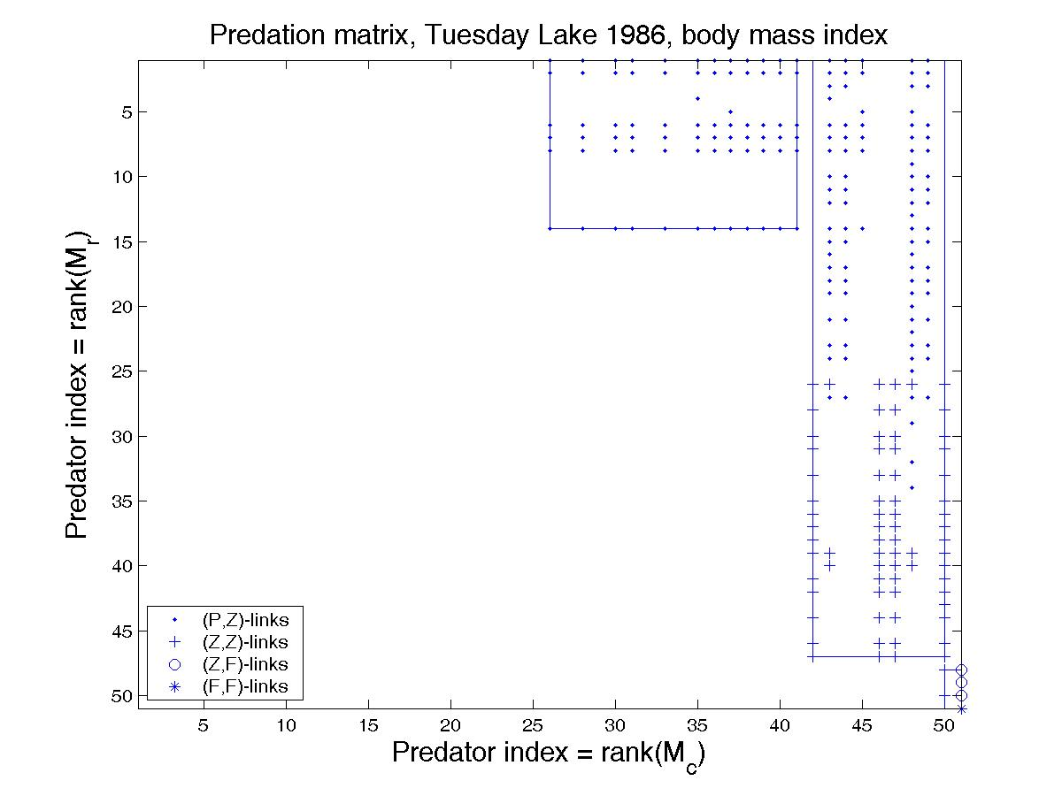
Figure A3: Trophic links (A, B) and ordered pairs (C, D) of species of Tuesday Lake with heavier predator than prey, in 1984 (A, C) and 1986 (B, D), showing l₁ length as functions of prey's log numerical abundance. Markers show a grouping of predator or consumer species into categories of similar numerical abundance. R, U and C groups represent rare, uncommon, and common. Solid lines are best fits to o and + symbols respectively. Dashed lines are the corresponding predictions of the Theoretical Predictions section.
3A:
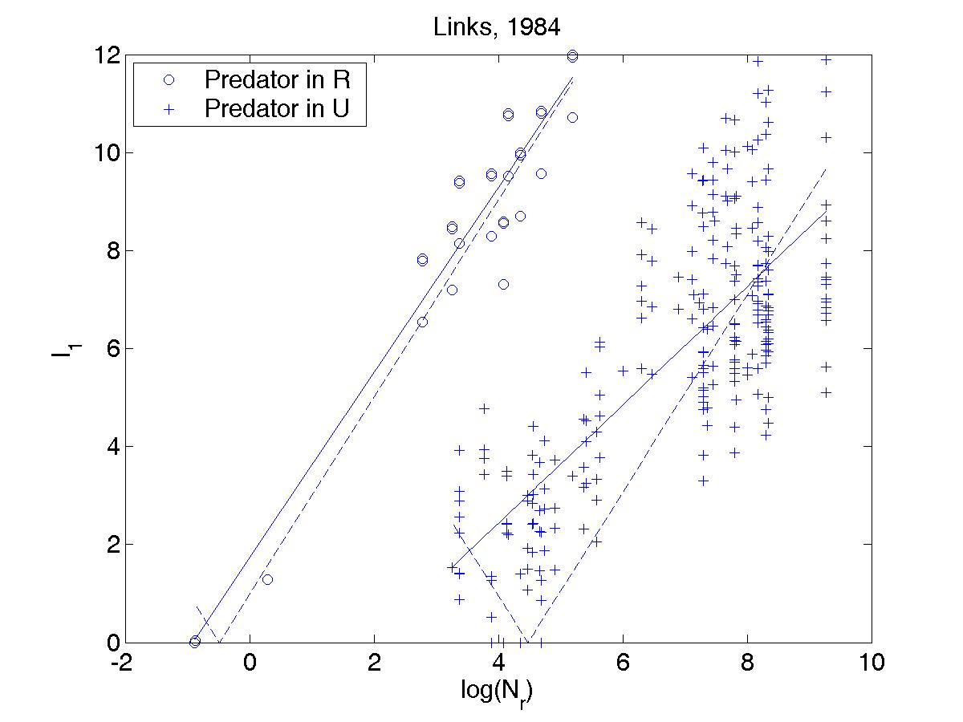
3B:
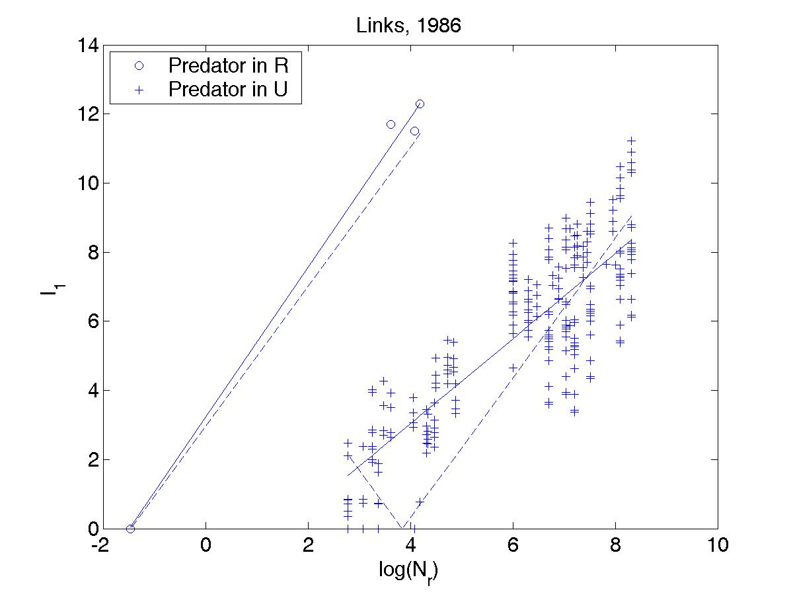

3C:
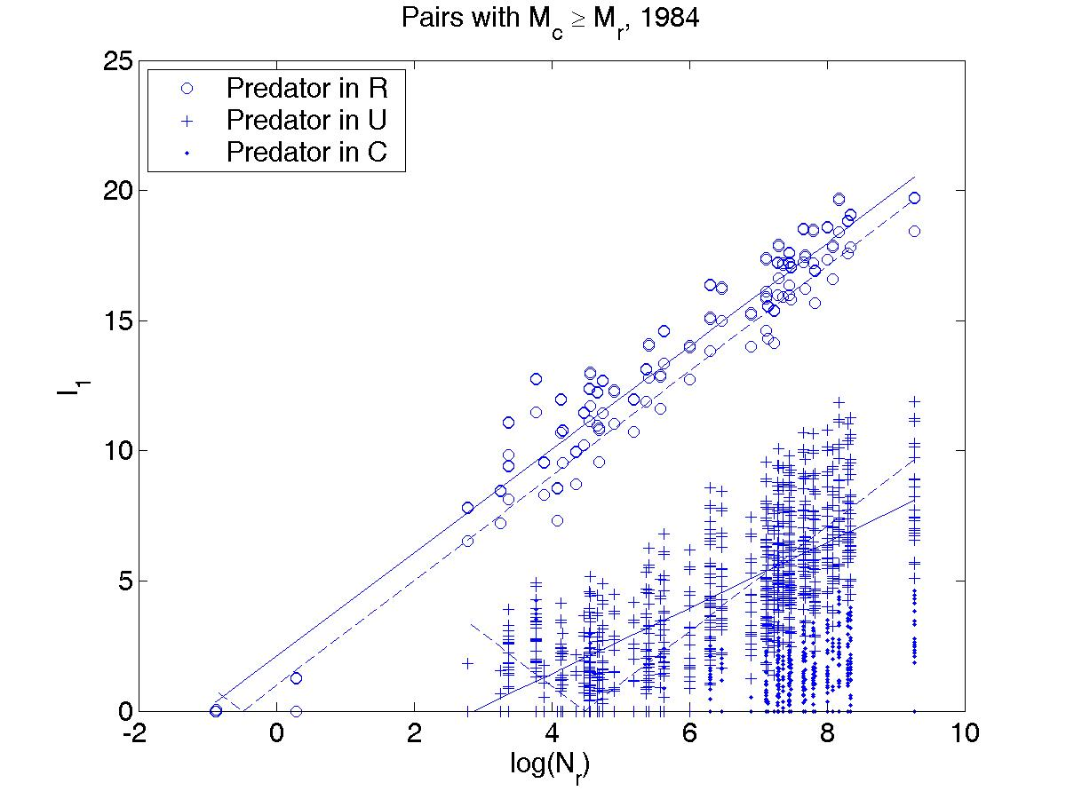
3D:
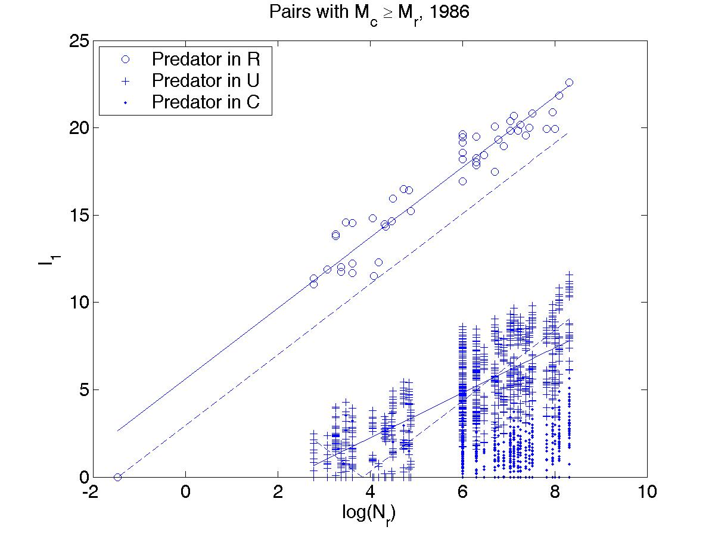
Figure A4: Same as Fig. 4 in the main text, but for 1986.
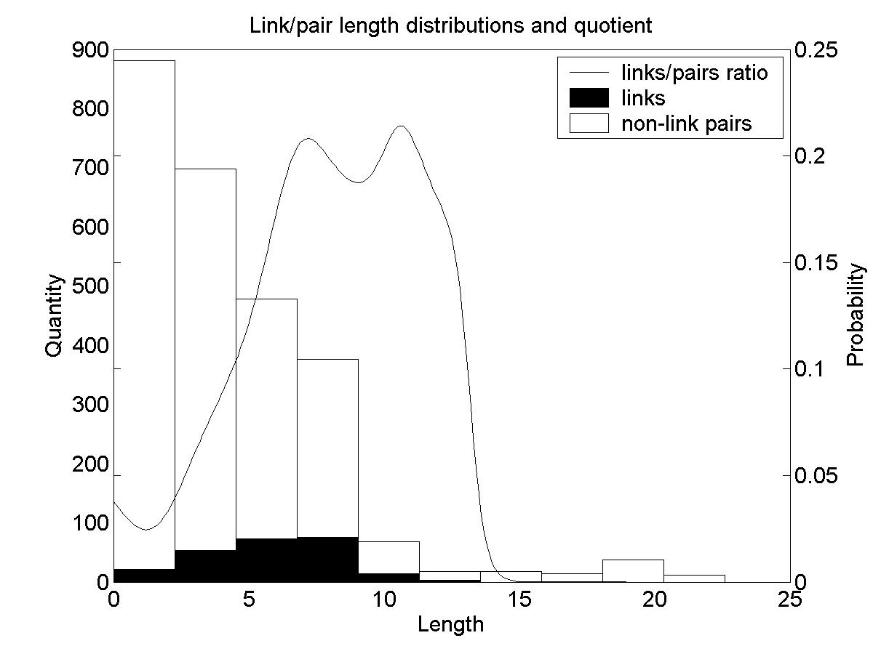
Appendix Tables A1 and A2
Groupings of all non-isolated species in Tuesday Lake in 1984 (Table A1) and 1986 (Table A2). The four columns after the species names give the group of each species with respect to each grouping. The PZF-grouping sorts the species into the functional categories of phytoplankton, zooplankton and fish. The BIT-grouping sorts the species into basal, intermediate and top groups. The M-grouping sorts the species into three groups of similar body mass (H, S and L, for heavy, standard weight and light). The N-grouping sorts the species into three groups of similar numerical abundance (R, U and C, for rare, uncommon and common). The number 0 corresponds to P, B, L and C groups respectively. The number 1 corresponds to Z, I, S and U groups respectively. The number 2 corresponds to F, T, H and R groups respectively. The species names were taken from Jonsson et al.
Table A1: 1984
Id # | Species name | PZF | BIT | M | N
1 | Nostoc sp. | 0 | 0 | 0 | 0
2 | Arthrodesmus sp. | 0 | 0 | 0 | 0
3 | Cryptomonas sp. 1 | 0 | 0 | 0 | 0
4 | Cryptomonas sp. 2 | 0 | 0 | 0 | 0
5 | Chroococcus dispersus | 0 | 0 | 0 | 0
6 | Closteriopsis longissimus | 0 | 0 | 0 | 0
7 | Dinobryon bavaricum | 0 | 0 | 0 | 0
8 | Dinobryon cylindricum | 0 | 0 | 0 | 0
9 | Dactylococcopsis fascicularis | 0 | 0 | 0 | 0
10 | Dictyosphaerium pulchellum | 0 | 0 | 0 | 0
11 | Dinobryon sertularia | 0 | 0 | 1 | 0
12 | Dinobryon sociale | 0 | 0 | 0 | 0
13 | Glenodinium quadridens | 0 | 0 | 1 | 0
14 | Microcystis aeruginosa | 0 | 0 | 1 | 0
15 | Mallomonas sp. 1 | 0 | 0 | 0 | 0
16 | Mallomonas sp. 2 | 0 | 0 | 0 | 0
17 | Unclassified flagellates | 0 | 0 | 0 | 0
18 | Peridinium limbatum | 0 | 0 | 1 | 0
19 | Peridinium cinctum | 0 | 0 | 1 | 0
20 | Peridinium pulsillum | 0 | 0 | 0 | 0
21 | Peridinium wisconsinense | 0 | 0 | 1 | 0
22 | Chromulina sp. | 0 | 0 | 0 | 0
23 | Selenastrum minutum | 0 | 0 | 0 | 0
24 | Synedra sp. | 0 | 0 | 1 | 1
25 | Trachelomonas sp. | 0 | 0 | 0 | 0
26 | Ascomorpha eucadis | 1 | 1 | 1 | 1
27 | Synchaeta sp. | 1 | 1 | 1 | 1
28 | Bosmina longirostris | 1 | 1 | 1 | 1
29 | Conochilus (solitary) | 1 | 1 | 1 | 1
30 | Cyclops varians rubellus | 1 | 1 | 1 | 1
31 | Diaphanosoma leuchtenbergianum | 1 | 1 | 1 | 1
32 | Daphnia pulex | 1 | 1 | 1 | 1
33 | Filinia longispina | 1 | 1 | 1 | 1
34 | Conochiloides dossuarius | 1 | 1 | 1 | 1
35 | Gastropus stylifer | 1 | 1 | 1 | 1
36 | Holopedium gibberum | 1 | 1 | 1 | 1
37 | Kellicottia sp. | 1 | 1 | 1 | 1
38 | Keratella cochlearis | 1 | 1 | 1 | 1
39 | Keratella testudo | 1 | 1 | 1 | 1
40 | Leptodiaptomus siciloides | 1 | 1 | 1 | 1
41 | Orthocyclops modestus | 1 | 1 | 1 | 1
42 | Ploesoma sp. | 1 | 1 | 1 | 1
43 | Polyarthra vulgaris | 1 | 1 | 1 | 1
44 | Trichocerca multicrinis | 1 | 1 | 1 | 1
45 | Trichocerca cylindrica | 1 | 1 | 1 | 1
46 | Tropocyclops prasinus | 1 | 1 | 1 | 1
47 | Chaoborus punctipennis | 1 | 1 | 1 | 1
48 | Phoxinus eos | 2 | 1 | 2 | 2
49 | Phoxinus neogaeus | 2 | 1 | 2 | 2
50 | Umbra limi | 2 | 2 | 2 | 2

Table A2: 1986
Id # | Species name | PZF | BIT | M | N
1 | Ankyra judayi | 0 | 0 | 0 | 0
2 | Cryptomonas sp. 1 | 0 | 0 | 0 | 0
3 | Cryptomonas sp. 3 | 0 | 0 | 0 | 0
4 | Cryptomonas sp. 4 | 0 | 0 | 0 | 0
5 | Chroococcus dispersus | 0 | 0 | 0 | 0
6 | Chroococcus limneticus | 0 | 0 | 0 | 0
7 | Cosmarium sp. | 0 | 0 | 0 | 0
8 | Closteriopsis longissimus | 0 | 0 | 0 | 0
9 | Dinobryon bavaricum | 0 | 0 | 0 | 0
10 | Dinobryon cylindricum | 0 | 0 | 0 | 0
11 | Dactylococcopsis fascicularis | 0 | 0 | 0 | 0
12 | Dictyosphaerium pulchellum | 0 | 0 | 0 | 0
13 | Dinobryon sertularia | 0 | 0 | 0 | 0
14 | Sphaerocystis schroeteri | 0 | 0 | 0 | 0
15 | Gloeocystis sp. | 0 | 0 | 0 | 0
16 | Glenodinium pulvisculus | 0 | 0 | 0 | 0
17 | Microcystis aeruginosa | 0 | 0 | 0 | 0
18 | unclassified microflagellates | 0 | 0 | 0 | 0
19 | Oocystis sp. 1 | 0 | 0 | 0 | 0
20 | Oocystis sp. 2 | 0 | 0 | 0 | 0
21 | Oscillatoria sp. | 0 | 0 | 0 | 0
22 | Peridinium limbatum | 0 | 0 | 0 | 0
23 | Peridinium pulsillum | 0 | 0 | 0 | 0
24 | Quadrigula lacustris | 0 | 0 | 0 | 0
25 | Quadrigula sp. 2 | 0 | 0 | 0 | 0
26 | Chromulina sp. | 0 | 0 | 0 | 0
27 | Schroederia setigera | 0 | 0 | 0 | 0
28 | Selenastrum minutum | 0 | 0 | 0 | 0
29 | Synedra sp. | 0 | 0 | 0 | 0
30 | Ascomorpha eucadis | 1 | 1 | 0 | 1
31 | Conochilus (colonial) | 1 | 2 | 1 | 1
32 | Conochiloides dossuarius | 1 | 1 | 0 | 1
33 | Cyclops varians rubellus | 1 | 1 | 1 | 1
34 | Diaptomus oregonensis | 1 | 1 | 1 | 1
35 | Daphnia pulex | 1 | 1 | 1 | 1
36 | Daphnia rosea | 1 | 1 | 1 | 1
37 | Gastropus hyptopus | 1 | 1 | 0 | 1
38 | Gastropus stylifer | 1 | 1 | 0 | 1
39 | Holopedium gibberum | 1 | 1 | 1 | 1
40 | Kellicottia bostoniensis | 1 | 1 | 0 | 1
41 | Kellicottia longispina | 1 | 1 | 0 | 1
42 | Keratella cochlearis | 1 | 1 | 0 | 1
43 | Keratella testudo | 1 | 1 | 0 | 1
44 | Orthocyclops modestus | 1 | 1 | 1 | 1
45 | Polyarthra vulgaris | 1 | 1 | 0 | 1
46 | Synchaeta sp. | 1 | 1 | 0 | 1
47 | Trichocerca cylindrica | 1 | 1 | 0 | 1
48 | Trichocerca multicrinis | 1 | 1 | 0 | 1
49 | Tropocyclops prasinus | 1 | 1 | 1 | 1
50 | Chaoborus punctipennis | 1 | 1 | 1 | 1
51 | Micropterus salmoides | 2 | 2 | 2 | 2

Table A3: The means and standard deviations of log(M) and log(N) and the number of species in each group from the BIT- and PZF-groupings for 1984 and 1986.

1984
 |  | log(M) |  | log(N)
Group | number of species | mean | std. | mean | std.
BIT-grouping
T (top) | 1 | -2.8894 | 0.0000 | -0.8794 | 0.0000
I (intermediate) | 24 | -8.5637 | 2.1257 | 4.0165 | 1.5341
B (basal) | 25 | -11.8079 | 0.9293 | 7.4426 | 0.7325
PZF-grouping
F (fish) | 3 | -2.9390 | 0.0535 | -0.4870 | 0.6768
Z (zooplankton) | 22 | -9.0728 | 1.3002 | 4.4080 | 0.7857
P (phytoplankton) | 25 | -11.8079 | 0.9293 | 7.4426 | 0.7325
1986
 |  | log(M) |  | log(N)
Group | # species | mean | std. | mean | std.
BIT-grouping
T (top) | 2 | -4.2732 | 5.0401 | 1.0774 | 3.6004
I (intermediate) | 20 | -9.0264 | 1.3611 | 3.8521 | 0.6719
B (basal) | 29 | -11.8412 | 0.8431 | 6.8922 | 0.7181
PZF-grouping
F (fish) | 1 | -0.7093 | 0.0000 | -1.4685 | 0.0000
Z (zooplankton) | 21 | -8.9697 | 1.3518 | 3.8412 | 0.6568
P (phytoplankton) | 29 | -11.8412 | 0.8431 | 6.8922 | 0.7181
Table A4: Comparison between fitted and theoretical equations in accounting for variance of link lengths as functions of body masses (first half of table) and numerical abundances (second half of table). The fitted equation 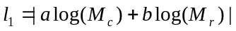 explains a large percentage of the variance of link lengths. The theoretical equation 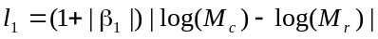 explains almost as much. The equations 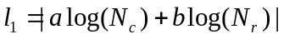 and 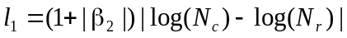 perform similarly. SSM is the sum of the squares of the differences of l₁ from the mean value of l₁. SSRF is the sum of the squares of the residuals of the real l₁ values from the best-fitted values. SSRT is the sum of the squares of the residuals of the real l₁ values from the theoretically predicted values. "Fit over mean" is the percent reduction in error in passing from the mean to the fit as a predictor (=(SSM-SSRF)/SSM). "Theory over mean" is the percent reduction in error in passing from the mean to theory as a predictor (=(SSM-SSRT)/SSM). "Fit over theory" is the percent reduction in error in passing from the theory to the fit as a predictor (=(SSRT-SSRF)/SSRT).
(M_{c}, M_{r}, l₁)
Links | a | b | SSM | SSRF | SSRT | Fit over mean | Theory over mean | Fit over theory
1984 | 1.6936 | -1.7625 | 2138.2 | 394.6 | 427.8 | 81.5% | 80.0% | 7.8%
1986 | 1.3918 | -1.5180 | 1587.2 | 288.2 | 349.5 | 81.8% | 78.0% | 17.5%
Pairs
1984 | 1.8537 | -1.8539 | 44623.0 | 3081.2 | 3086.0 | 93.10% | 93.08% | 0.16%
1986 | 1.7702 | -1.7702 | 34815.5 | 3588.3 | 3603.4 | 89.69% | 89.65% | 0.42%
(N_{c}, N_{r}, l₁)
Links | a | b | SSM | SSRF | SSRT | Fit over mean | Theory over mean | Fit over theory
1984 | 1.7491 | -1.8675 | 2138.2 | 433.3 | 456.7 | 79.7% | 78.6% | 5.1%
1986 | 1.1771 | -1.6142 | 1587.2 | 400.6 | 480.9 | 74.8% | 69.7% | 16.7%
Pairs
1984 | 2.0298 | -2.0298 | 44623.0 | 3714.2 | 3716.7 | 91.68% | 91.67% | 0.07%
1986 | 2.0595 | -2.0595 | 34815.5 | 4902.1 | 4921.7 | 85.92% | 85.86% | 0.40%
Table A5: Coefficients of a linear regression of α versus log(M_{r}) and log(M_{c}) (first half of the table) and α versus log(N_{r}) and log(N_{c}) (second half of the table) over links and over pairs with heavier predator, where α is the slope of a link (pair). Columns 2 and 3 contain the slope coefficient of the independent variable in the column heading. The 99% confidence intervals for fitted values are in parentheses.

(log(M_{r}), log(M_{c}), α)
 | Links
 | log(M_{r}) | log(M_{c}) | constant
1984 | -0.019 (-0.897, 0.859) | -0.195 (-1.016, 0.626) | -2.897 (-9.189, 3.394)
1986 | 0.185 (-1.212, 1.583) | 0.072 (-1.396, 1.541) | 1.859 (-11.268, 14.986)
 | Pairs with heavier predator
1984 | 0.055 (-0.298, 0.408) | -0.144 (-0.336, 0.048) | -1.599 (-5.224, 2.026)
1986 | 0.323 (-0.026, 0.673) | -0.174 (-0.354, 0.006) | 1.452 (-2.241, 5.145)
(log(N_{r}), log(N_{c}), α)
 | Links
 | log(N_{r}) | log(N_{c}) | constant
1984 | 0.080 (-0.571, 0.732) | 0.069 (-0.693, 0.830) | -1.936 (-5.846, 1.973)
1986 | -0.394 (-1.545, 0.758) | 0.690 (-1.554, 2.933) | -0.926 (-9.929, 8.077)
 | Pairs with heavier predator
1984 | 0.006 (-0.308, 0.320) | 0.115 (-0.090, 0.319) | -1.527 (-3.586, 0.533)
1986 | -0.354 (-0.654, -0.054) | 0.228 (0.020, 0.436) | 0.535 (-1.387, 2.456)

Table A6: Coefficients of linear best-fits and predictions of theory for the distributions (log(M_{r}), l₁) (first half of table) and (log(N_{r}), l₁) (second half of table) over links and over pairs with predator at least as heavy as prey. Theory predicts 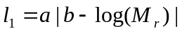 (first half) and 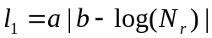 (second half). This table contains -a and ab (first half) and a and –ab (second half), the values that are directly comparable to the fitted slope and y-intercept, respectively. The 99% confidence intervals are in parentheses.
(log(M_{r}), l₁)
 | Theory |  | Fitted
 | -a | ab | Slope | y-intercept
 | Links
H preds.
1984 | -1.8413 | -5.4116 | -1.7910 (-2.0583, -1.5237) | -4.6338 (-6.6248, -2.6428)
1986 | -1.7461 | -1.2385 | -1.8392 (-2.7233, -0.9551) | -1.2575 (-6.7152, 4.2001)
S preds.
1984 | -1.8413 | -17.3590 | -1.2803 (-1.4644, -1.0963) | -8.8486 (-10.9886, -6.7087)
1986 | -1.7461 | -13.1986 | -1.6644 (-1.7787, -1.5500) | -12.4956 (-13.7523, -11.2390)
 | Pairs with predator at least as heavy as prey
H preds.
1984 | -1.8413 | -5.4116 | -1.8152 (-1.9148, -1.7157) | -5.0095 (-6.0516, -3.9674)
1986 | -1.7461 | -1.2385 | -1.7461 (-1.9065, -1.5857) | -1.5586 (-3.2708, 0.1535)
S preds.
1984 | -1.8413 | -17.3590 | -1.1757 (-1.3131, -1.0384) | -9.0023 (-10.5660, -7.4387)
1986 | -1.7461 | -13.1986 | -1.7124 (-1.7948, -1.6300) | -12.8621 (-13.7709, -11.9534)
(log(N_{r}), l₁)
 | Theory |  | Fitted
 | a | -ab | Slope | y-intercept
 | Links
R preds.
1984 | 2.0141 | 0.9809 | 1.8891 (1.6012, 2.1770) | 1.7305 (0.6256, 2.8355)
1986 | 2.0191 | 2.9650 | 2.1654 (0.9376, 3.3932) | 3.2310 (-1.0885, 7.5504)
U preds.
1984 | 2.0141 | -9.0175 | 1.2074 (1.0364, 1.3784) | -2.3973 (-3.6074, -1.1871)
1986 | 2.0191 | -7.7558 | 1.2309 (1.0906, 1.3713) | -1.8909 (-2.7895, -0.9923)
 | Pairs with predator at least as heavy as prey
R preds.
1984 | 2.0141 | 0.9809 | 1.9828 (1.8662, 2.0994) | 2.1099 (1.3956, 2.8242)
1986 | 2.0191 | 2.9650 | 2.0191 (1.8000, 2.2381) | 5.6235 (4.3541, 6.8928)
U preds.
1984 | 2.0141 | -9.0175 | 1.2614 (1.1516, 1.3712) | -3.6146 (-4.3539, -2.8754)
1986 | 2.0191 | -7.7558 | 1.2895 (1.1855, 1.3936) | -2.9246 (-3.5768, -2.2724)
Table A7: Results of statistical tests of the normality of distributions of angles. Cannibalism has always been removed. In columns 2 and 4, the circle was broken at -135°=225°. The first number in each box in columns 2, 3, 4, 5 is the number of data points in that category, the second is the Jarque-Bera p-value, and the third is the Lilliefors p-value. The Lilliefors test is based on simulation only for p-values between 0.01 and 0.2, so any p-value outside this range is reported as <0.01 or >0.2. Jarque-Bera p-values that are less than 0.001 are reported as <0.001 for readability. NA means the number of data points is too few for the Matlab test. The Lilliefors test requires at least 4 data points, and the Jarque-Bera could take any positive number of data points. Conclusions of both tests are suspect when data are few.

 | links: | links with angle between 45° and 225°: | ordered pairs: | pairs with angle between 45° and 225°:
overall distributions:
1984 | 264/<0.001/<0.01 | 258/<0.001/<0.01 | 2450/<0.001/<0.01 | 1225/<0.001/<0.01
1986 | 236/<0.001/<0.01 | 229/<0.001/<0.01 | 2550/<0.001/<0.01 | 1275/0.0021/<0.01
symmetric groups:
PZF-grouping of function
1984 (P,P) | 0/NA/NA | 0/NA/NA | 600/<0.001/<0.01 | 300/0.0252/0.0446
1986 (P,P) | 0/NA/NA | 0/NA/NA | 812/<0.001/<0.01 | 406/0.0002/<0.01
1984 (Z,Z) | 69/<0.001/<0.01 | 63/0.7043/>0.2 | 462/<0.001/<0.01 | 231/0.0018/<0.01
1986 (Z,Z) | 68/<0.001/<0.01 | 61/0.5431/>0.2 | 420/<0.001/<0.01 | 210/0.0004/<0.01
1984 (F,F) | 2/0.7297/NA | 2/0.7297/NA | 6/0.6258/>0.2 | 3/0.6858/NA
1986 (F,F) | 0/NA/NA | 0/NA/NA | 0/NA/NA | 0/NA/NA
M-grouping of body mass
1984 (L,L) | 0/NA/NA | 0/NA/NA | 306/<0.001/<0.01 | 153/0.0394/0.11017
1986 (L,L) | 74/0.5951/0.0722 | 74/0.5951/0.0722 | 1640/<0.001/<0.01 | 820/0.0467/<0.01
1984 (S,S) | 83/<0.001/0.0158 | 77/0.5456/>0.2 | 812/<0.001/<0.01 | 406/0.4738/>0.2
1986 (S,S) | 15/0.7771/>0.2 | 8/0.5847/0.1303 | 72/0.1436/0.0483 | 36/0.1134/0.0188
1984 (H,H) | 2/0.7297/NA | 2/0.7297/NA | 6/0.6258/>0.2 | 3/0.6858/NA
1986 (H,H) | 0/NA/NA | 0/NA/NA | 0/NA/NA | 0/NA/NA
N-grouping of abundance
1984 (C,C) | 0/NA/NA | 0/NA/NA | 522/<0.001/<0.01 | 276/0.0124/<0.01
1986 (C,C) | 0/NA/NA | 0/NA/NA | 812/<0.001/<0.01 | 406/0.0002/<0.01
1984 (U,U) | 70/<0.001/<0.01 | 64/0.7583/>0.2 | 506/<0.001/<0.01 | 253/0.0081/<0.01
1986 (U,U) | 68/<0.001/<0.01 | 61/0.5431/>0.2 | 420/<0.001/<0.01 | 210/0.0004/<0.01
1984 (R,R) | 2/0.7297/NA | 2/0.7297/NA | 6/0.6258/>0.2 | 3/0.6858/NA
1986 (R,R) | 0/NA/NA | 0/NA/NA | 0/NA/NA | 0/NA/NA
BIT-grouping of web location
1984 (B,B) | 0/NA/NA | 0/NA/NA | 600/<0.001/<0.01 | 300/0.0252/0.0446
1986 (B,B) | 0/NA/NA | 0/NA/NA | 812/<0.001/<0.01 | 406/0.0002/<0.01
1984 (I,I) | 87/<0.001/<0.01 | 81/0.3121/>0.2 | 552/<0.001/<0.01 | 276/0.0005/<0.01
1986 (I,I) | 68/<0.001/<0.01 | 61/0.5431/>0.2 | 380/<0.001/<0.01 | 190/0.0014/<0.01
1984 (T,T) | 0/NA/NA | 0/NA/NA | 0/NA/NA | 0/NA/NA
1986 (T,T) | 0/NA/NA | 0/NA/NA | 2/0.7297/NA | 1/1/NA
non-symmetric groups:
1984 (P,Z) | 166/0.0017/0.0307 | 166/0.0017/0.0307 | 550/<0.001/<0.01 | 548/<0.001/<0.01
1986 (P,Z) | 165/0.5036/>0.2 | 165/0.5036/>0.2 | 609/<0.001/<0.01 | 609/<0.001/<0.01
1984 (P,F) | 0/NA/NA | 0/NA/NA | 75/0.6191/>0.2 | 75/0.6191/>0.2
1986 (P,F) | 0/NA/NA | 0/NA/NA | 29/0.8054/>0.2 | 29/0.8054/>0.2
1984 (Z,P) | 0/NA/NA | 0/NA/NA | 550/<0.001/<0.01 | 2/0.7297/NA
1986 (Z,P) | 0/NA/NA | 0/NA/NA | 609/<0.001/<0.01 | 0/NA/NA
1984 (Z,F) | 27/0.9349/>0.2 | 27/0.9349/>0.2 | 66/0.9947/>0.2 | 66/0.9947/>0.2
1986 (Z,F) | 3/0.7110/NA | 3/0.7110/NA | 21/0.5571/>0.2 | 21/0.5571/>0.2
1984 (F,P) | 0/NA/NA | 0/NA/NA | 75/0.6191/>0.2 | 0/NA/NA
1986 (F,P) | 0/NA/NA | 0/NA/NA | 29/0.8054/>0.2 | 0/NA/NA
1984 (F,Z) | 0/NA/NA | 0/NA/NA | 66/0.9947/>0.2 | 0/NA/NA
1986 (F,Z) | 0/NA/NA | 0/NA/NA | 21/0.5571/>0.2 | 0/NA/NA
1984 (L,S) | 152/0.0020/<0.01 | 152/0.0020/<0.01 | 522/<0.001/<0.01 | 520/<0.001/<0.01
1986 (L,S) | 144/<0.001/<0.01 | 144/<0.001/<0.01 | 369/<0.001/<0.01 | 369/<0.001/0.01
1984 (L,H) | 0/NA/NA | 0/NA/NA | 54/0.6991/>0.2 | 54/0.6991/>0.2
1986 (L,H) | 0/NA/NA | 0/NA/NA | 41/0.3994/0.1363 | 41/0.3994/0.1363
1984 (S,L) | 0/NA/NA | 0/NA/NA | 522/<0.001/<0.01 | 2/0.7297/NA
1986 (S,L) | 0/NA/NA | 0/NA/NA | 369/<0.001/<0.01 | 0/NA/NA
1984 (S,H) | 27/0.9349/>0.2 | 27/0.9349/>0.2 | 87/0.3630/0.1204 | 87/0.3630/0.1204
1986 (S,H) | 3/0.7110/NA | 3/0.7110/NA | 9/0.6161/>0.2 | 9/0.6161/>0.2
1984 (H,L) | 0/NA/NA | 0/NA/NA | 54/0.6991/>0.2 | 0/NA/NA
1986 (H,L) | 0/NA/NA | 0/NA/NA | 41/0.3994/0.1363 | 0/NA/NA
1984 (H,S) | 0/NA/NA | 0/NA/NA | 87/0.3630/0.1204 | 0/NA/NA
1986 (H,S) | 0/NA/NA | 0/NA/NA | 9/0.6161/>0.2 | 0/NA/NA
1984 (C,U) | 165/0.0021/0.0366 | 165/0.0021/0.0366 | 552/<0.001/<0.01 | 552/<0.001/<0.01
1986 (C,U) | 165/0.5036/>0.2 | 165/0.5036/>0.2 | 609/<0.001/<0.01 | 609/<0.001/<0.01
1984 (C,R) | 0/NA/NA | 0/NA/NA | 72/0.6454/>0.2 | 72/0.6454/>0.2
1986 (C,R) | 0/NA/NA | 0/NA/NA | 29/0.8054/>0.2 | 29/0.8054/>0.02
1984 (U,C) | 0/NA/NA | 0/NA/NA | 552/<0.001/<0.01 | 0/NA/NA
1986 (U,C) | 0/NA/NA | 0/NA/NA | 609/<0.001/<0.01 | 0/NA/NA
1984 (U,R) | 27/0.9349/>0.2 | 27/0.9349/>0.2 | 69/0.9550/>0.2 | 69/0.9550/>0.2
1986 (U,R) | 3/0.7110/NA | 3/0.7110/NA | 21/0.5571/>0.2 | 21/0.5571/>0.2
1984 (R,C) | 0/NA/NA | 0/NA/NA | 72/0.6454/>0.2 | 0/NA/NA
1986 (R,C) | 0/NA/NA | 0/NA/NA | 29/0.8054/>0.2 | 0/NA/NA
1984 (R,U) | 0/NA/NA | 0/NA/NA | 69/0.9550/>0.2 | 0/NA/NA
1986 (R,U) | 0/NA/NA | 0/NA/NA | 21/0.5571/>0.2 | 0/NA/NA
1984 (B,I) | 166/0.0017/0.0307 | 166/0.0017/0.0307 | 600/<0.001/<0.01 | 598/<0.001/<0.01
1986 (B,I) | 158/0.4973/>0.2 | 158/0.4973/>0.2 | 580/<0.001/<0.01 | 580/<0.001/<0.01
1984 (B,T) | 0/NA/NA | 0/NA/NA | 25/0.6448/>0.2 | 25/0.6448/>0.2
1986 (B,T) | 7/0.594/0.1078 | 7/0.594/0.1078 | 58/0.1427/>0.2 | 58/0.1427/>0.2
1984 (I,B) | 0/NA/NA | 0/NA/NA | 600/<0.001/<0.01 | 2/0.7297/NA
1986 (I,B) | 0/NA/NA | 0/NA/NA | 580/<0.001/<0.01 | 0/NA/NA
1984 (I,T) | 11/0.7335/<0.01 | 11/0.7335/<0.01 | 24/<0.001/<0.01 | 24/<0.001/<0.01
1986 (I,T) | 3/0.7110/NA | 3/0.7110/NA | 40/<0.001/<0.01 | 33/<0.001/<0.01
1984 (T,B) | 0/NA/NA | 0/NA/NA | 25/0.6448/>0.2 | 0/NA/NA
1986 (T,B) | 0/NA/NA | 0/NA/NA | 58/0.1427/>0.2 | 0/NA/NA
1984 (T,I) | 0/NA/NA | 0/NA/NA | 24/<0.001/<0.01 | 0/NA/NA
1986 (T,I) | 0/NA/NA | 0/NA/NA | 40/<0.001/<0.01 | 7/0.5999/>0.2

Table A8: Results of statistical tests of the normality of distributions of lengths. Cannibalism has never been removed. Column 6 considers all cannibalistic pairs plus one from each pair ((x, y) and (y, x)) of non-cannibalistic pairs. Columns 3, 5 and 7 are the authors' opinion, based on the relevant histogram, of whether the distribution could be normal, truncated at zero. Possible answers are y for yes, n for no, and NA if there were fewer than 20 data. The answer is y if the distribution is verified to be (un-truncated) normal via the testing methods, except if there were fewer than 20 data. These opinions lean toward saying more distributions could be truncated-at-zero normal. Otherwise, the layout of this table is the same as that of Appendix Table A7.

 | links: |  | ordered pairs: |  | half of the pairs:
overall distributions:
1984 | 269/0.0311/0.0663 | y | 2500/<0.001/<0.01 | y | 1275/<0.001/<0.01 | y
1986 | 241/0.1780/0.1066 | y | 2601/<0.001/<0.01 | y | 1326/<0.001/<0.01 | y
symmetric groups:
1984 (P,P) | 0/NA/NA | NA | 625/<0.001/<0.01 | y | 325/<0.001/<0.01 | y
1986 (P,P) | 0/NA/NA | NA | 841/<0.001/<0.01 | y | 435/<0.001/0.0200 | y
1984 (Z,Z) | 73/0.8447/>0.2 | y | 484/<0.001/<0.01 | y | 253/0.0011/<0.01 | y
1986 (Z,Z) | 72/0.2522/0.0464 | y | 441/0.0010/<0.01 | y | 231/0.0177/0.0352 | y
1984 (F,F) | 3/0.6859/NA | NA | 9/0.4041/<0.01 | NA | 6/0.5367/<0.01 | NA
1986 (F,F) | 1/1/NA | NA | 1/1/NA | NA | 1/1/NA | NA
1984 (L,L) | 0/NA/NA | NA | 324/0.0008/<0.01 | y | 171/0.0350/0.0489 | y
1986 (L,L) | 74/0.6263/>0.2 | y | 1681/<0.001/<0.01 | y | 861/<0.001/<0.01 | y
1984 (S,S) | 87/0.0262/0.0263 | y | 841/<0.001/<0.01 | y | 435/<0.001/<0.01 | y
1986 (S,S) | 19/0.3826/<0.01 | NA | 81/0.1186/0.0185 | y | 45/0.2513/>0.02 | y
1984 (H,H) | 3/0.6859/NA | NA | 9/0.4041/<0.01 | NA | 6/0.5367/<0.01 | NA
1986 (H,H) | 1/1/NA | NA | 1/1/NA | NA | 1/1/NA | NA
1984 (C,C) | 0/NA/NA | NA | 576/<0.001/<0.01 | y | 300/0.0008/0.0165 | y
1986 (C,C) | 0/NA/NA | NA | 841/<0.001/<0.01 | y | 435/<0.001/0.0200 | y
1984 (U,U) | 74/0.7805/>0.2 | y | 529/<0.001/<0.01 | y | 276/0.0004/<0.01 | y
1986 (U,U) | 72/0.2522/0.0464 | y | 441/0.0010/<0.01 | y | 231/0.0177/0.0352 | y
1984 (R,R) | 3/0.6859/NA | NA | 9/0.4041/<0.01 | NA | 6/0.5367/<0.01 | NA
1986 (R,R) | 1/1/NA | NA | 1/1/NA | NA | 1/1/NA | NA
1984 (B,B) | 0/NA/NA | NA | 625/<0.001/<0.01 | y | 325/<0.001/<0.01 | y
1986 (B,B) | 0/NA/NA | NA | 841/<0.001/<0.01 | y | 435/<0.001/0.0200 | y
1984 (I,I) | 91/0.0003/<0.01 | y | 576/<0.001/<0.01 | n | 300/<0.001/<0.01 | y
1986 (I,I) | 72/0.2522/0.0464 | y | 400/0.0020/0.0312 | y | 210/0.0246/0.0422 | y
1984 (T,T) | 1/1/NA | NA | 1/1/NA | NA | 1/1/NA | NA
1986 (T,T) | 1/1/NA | NA | 4/0.6095/0.1822 | NA | 3/0.6857/NA | NA
non-symmetric groups:
1984 (P,Z) | 166/0.0598/0.0222 | y | 550/0.0058/0.1641 | y | 550/0.0058/0.1641 | y
1986 (P,Z) | 165/0.8010/>0.2 | y | 609/0.0023/<0.01 | n | 609/0.0023/<0.01 | n
1984 (P,F) | 0/NA/NA | NA | 75/0.4769/>0.2 | y | 75/0.4769/>0.2 | y
1986 (P,F) | 0/NA/NA | NA | 29/0.8830/>0.2 | y | 29/0.8830/>0.2 | y
1984 (Z,P) | 0/NA/NA | NA | 550/0.0058/0.1641 | y | 550/0.0058/0.1641 | y
1986 (Z,P) | 0/NA/NA | NA | 609/0.0023/<0.01 | n | 609/0.0023/<0.01 | n
1984 (Z,F) | 27/0.6583/>0.2 | y | 66/0.2718/0.0998 | y | 66/0.2718/0.0998 | y
1986 (Z,F) | 3/0.6953/NA | NA | 21/0.3786/0.0424 | y | 21/0.3786/0.0424 | y
1984 (F,P) | 0/NA/NA | NA | 75/0.4769/>0.2 | y | 75/0.4769/>0.2 | y
1986 (F,P) | 0/NA/NA | NA | 29/0.8830/>0.2 | y | 29/0.8830/>0.2 | y
1984 (F,Z) | 0/NA/NA | NA | 66/0.2718/0.0998 | y | 66/0.2718/0.0998 | y
1986 (F,Z) | 0/NA/NA | NA | 21/0.3786/0.0424 | y | 21/0.3786/0.0424 | y
1984 (L,S) | 152/0.0651/0.0165 | y | 522/0.0006/0.0622 | y | 522/0.0006/0.0622 | y
1986 (L,S) | 144/0.0193/<0.01 | n | 369/<0.001/0.01 | n | 369/<0.001/0.01 | n
1984 (L,H) | 0/NA/NA | NA | 54/0.6319/>0.2 | y | 54/0.6319/>0.2 | y
1986 (L,H) | 0/NA/NA | NA | 41/0.2310/ | n | 41/0.2310/ | n
1984 (S,L) | 0/NA/NA | NA | 522/0.0006/0.0622 | y | 522/0.0006/0.0622 | y
1986 (S,L) | 0/NA/NA | NA | 369/<0.001/0.01 | n | 369/<0.001/0.01 | n
1984 (S,H) | 27/0.6583/>0.2 | y | 87/0.3546/>0.2 | y | 87/0.3546/>0.2 | y
1986 (S,H) | 3/0.6953/NA | NA | 9/0.7160/>0.2 | NA | 9/0.7160/>0.2 | NA
1984 (H,L) | 0/NA/NA | NA | 54/0.6319/>0.2 | y | 54/0.6319/>0.2 | y
1986 (H,L) | 0/NA/NA | NA | 41/0.2310/0.0482 | n | 41/0.2310/0.0482 | n
1984 (H,S) | 0/NA/NA | NA | 87/0.3546/>0.2 | y | 87/0.3546/>0.2 | y
1986 (H,S) | 0/NA/NA | NA | 9/0.7160/>0.2 | NA | 9/0.7160/>0.2 | NA
1984 (C,U) | 165/0.0678/0.0238 | y | 552/0.0019/0.0426 | y | 552/0.0019/0.0426 | y
1986 (C,U) | 165/0.8010/>0.2 | y | 609/0.0023/<0.01 | n | 609/0.0023/<0.01 | n
1984 (C,R) | 0/NA/NA | NA | 72/0.4537/>0.02 | y | 72/0.4537/>0.02 | y
1986 (C,R) | 0/NA/NA | NA | 29/0.8830/>0.2 | y | 29/0.8830/>0.2 | y
1984 (U,C) | 0/NA/NA | NA | 552/0.0019/0.0426 | y | 552/0.0019/0.0426 | y
1986 (U,C) | 0/NA/NA | NA | 609/0.0023/<0.01 | n | 609/0.0023/<0.01 | n
1984 (U,R) | 27/0.6583/>0.02 | y | 69/0.2249/0.1504 | y | 69/0.2249/0.1504 | y
1986 (U,R) | 3/0.6953/NA | NA | 21/0.3786/0.0424 | y | 21/0.3786/0.0424 | y
1984 (R,C) | 0/NA/NA | NA | 72/0.4537/>0.2 | y | 72/0.4537/>0.2 | y
1986 (R,C) | 0/NA/NA | NA | 29/0.8830/>0.2 | y | 29/0.8830/>0.2 | y
1984 (R,U) | 0/NA/NA | NA | 69/0.2249/0.1504 | y | 69/0.2249/0.1504 | y
1986 (R,U) | 0/NA/NA | NA | 21/0.3786/0.0424 | y | 21/0.3786/0.0424 | y
1984 (B,I) | 166/0.0598/0.0222 | y | 600/<0.001/<0.01 | n | 600/<0.001/<0.01 | n
1986 (B,I) | 158/0.7730/>0.2 | y | 580/0.0019/<0.01 | n | 580/0.0019/<0.01 | n
1984 (B,T) | 0/NA/NA | NA | 25/0.6565/>0.2 | y | 25/0.6565/>0.2 | y
1986 (B,T) | 7/0.6225/>0.2 | NA | 58/0.0136/<0.01 | n | 58/0.0136/<0.01 | n
1984 (I,B) | 0/NA/NA | NA | 600/<0.001/<0.01 | n | 600/<0.001/<0.01 | n
1986 (I,B) | 0/NA/NA | NA | 580/0.0019/<0.01 | n | 580/0.0019/<0.01 | n
1984 (I,T) | 11/0.3039/<0.01 | NA | 24/0.0001/0.0285 | n | 24/0.0001/0.0285 | n
1986 (I,T) | 3/0.6953/NA | NA | 40/0.0606/<0.01 | n | 40/0.0606/<0.01 | n
1984 (T,B) | 0/NA/NA | NA | 25/0.6565/>0.2 | y | 25/0.6565/>0.2 | y
1986 (T,B) | 0/NA/NA | NA | 58/0.0136/<0.01 | n | 58/0.0136/<0.01 | n
1984 (T,I) | 0/NA/NA | NA | 24/0.0001/0.0285 | n | 24/0.0001/0.0285 | n
1986 (T,I) | 0/NA/NA | NA | 40/0.0606/<0.01 | n | 40/0.0606/<0.01 | n

Table A9: Boundaries of the blocks selected in the "block equivalence" model, in the form [a,b] by [c,d], where a and b are the upper and lower limits of the prey index, and c and d are the upper and lower limits of the predator index. Index is rank body mass.

 | 1984 | 1986
Block 1 | [1, 10] by [20, 39] | [1, 14] by [26, 41]
Block 2 | [1, 45] by [40, 47] | [1, 47] by [42, 50]
Block 3 | [39, 50] by [48, 50] | [48, 51] by [50, 51]
Additional Results
The distribution of angles over all ordered pairs (cannibalistic pairs excluded) was bimodal and therefore clearly not normal. Bimodality was inevitable because, as mentioned in Methods, any pair (x, y) with x different from y had a corresponding pair (y, x) whose angle differed by 180°. When only pairs with angles between 45° and 225° were considered to eliminate bimodality, the distributions were still not normal in 1984 or in 1986. Given a grouping, one can consider the angle distribution over ordered pairs within a certain group (A, B). Symmetric groups (those for which A=B) gave bimodal distributions, and were therefore never normal, except for the (S, S) group in 1986, and some other groups for which there were six or fewer pairs under consideration (where tests of normality had little power). Considering only pairs within the given symmetric grouping that had angle between 45° and 225° eliminated bimodality, but no symmetric group in any grouping was normal in both years except the group (S, S). Other groups in the M-grouping and other groupings were sometimes normal, but never in both years.
Let 0 represent the P, L, C and B groups in their respective groupings. Let 1 represent the Z, S, U and I groups in their groupings, and let 2 represent the F, L, R and T groups. Thus 1 represents the intermediate group in each grouping, while 0 and 2 represent the alternative extreme groups. Then for all groupings except BIT, the non-symmetric groups (0,2), (2,0), (1,2), and (2,1) had normal ordered pair distributions of angle, while the (0,1) and (1,0) groups did not. In the BIT grouping, only (0,2) and (2,0) were normal. These results held in both years. For the PZF-, M-, and N-groupings, groups 1 and 2, and groups 0 and 2 were far apart on log(M) versus log(N) axes, while groups 0 and 1 were comparatively close. Under the BIT-grouping, groups 1 and 2 were also fairly close.
Matlab Code for Models
The following Matlab code calculates distributions of Jarque-Bera and Lilliefors statistics coming from each of the six models discussed in Models Used.

Cascade Model:
function [jbstat,lilliestat]=cascade(M,N,L,numiters)
%function [jbstat,lilliestat]=cascade(M,N,L,numiters)
%This function takes a body mass distribution M, and an identically indexed numerical
%abundance dist. N. It sorts the M dist. in increasing order, puts the N dist. in the same
% order, and uses this order as the cascade model order, and chooses links for a model
%web using the cascade model, where L is the number of links it will choose. It chooses
%these links randomly and uniformly from the strictly-upper-triangular part of a
%predation matrix based on the indexing order it gets from M. It then computes the link
%length distribution and its Jarque-Bera and Lilliefors statistics. It does this "numiters"
%times, returning all the statistics in two vectors, one for Jarque-Bera and one for
%Lilliefors.
%
%27 May 2003

%sort the M and N
[M,I]=sort(M);
N=N(I);
%compute logs
lM=log10(M);
lN=log10(N);
n=length(N);

jbstat=[];
lilliestat=[];
for counter=1:numiters

%get L different values randomly chosen between 1 and (n^2-n)/2, since there are
%(n^2-n)/2 entries in the upper triangle.
indexmat=randperm((n^2-n)/2);
indexmat=indexmat(1:L)';

%get the indices - if you fill the upper-triangular part of a matrix one column at a time
%from the elements of a vector, the following equations give the relationship between
%the index in the vector and the indices in the matrix
J=next_below_not_equal((-1+sqrt(8.*indexmat+1))./2)+2;
I=indexmat-((J-2)./2).*(J-1);

%for testing purposes
%predmat=zeros(n,n);
%predmat(sub2ind([n n],I,J))=1;
%predmat
%return;

%compute the link lengths
lengths=abs(lM(J)-lM(I))+abs(lN(J)-lN(I));

%do the statistical tests and keep the statistic in each case
[h,p,stat]=jbtest(lengths);
jbstat=[jbstat stat];
[h,p,stat]=lillietest(lengths);
lilliestat=[lilliestat stat];

end

function result=next_below_not_equal(in)
%function result=next_below_not_equal(in)
%Takes a matrix and returns a matrix that has each entry equal to the next
%integer below, but not equal to the corresponding entry in the input
%matrix.
%
%27 May 2003

result=floor(in);
result=result-(result==in);

Niche Model:
function [jbstat,lilliestat]=neowilliams2(M,N,C,numiters)
%function [jbstat,lilliestat]=neowilliams2(M,N,C,numiters)
%This function takes a body mass distribution, and a correspondingly indexed numerical
%abundance distribution. It sorts the M distribution, and puts the N distribution in the
%same order. It then uses this order as the index order in the food web model of
%Williams and Martinez in their 2000 Nature article. The "niche value"
%n_i that Williams and Martinez use is the normalized log10 of this body mass.
%The log10 is used because they choose species index values
%randomly and uniformly, roughly achieved by log10(M), but not by M without
%the log10. The normalization is done by choosing as many uniformly distributed
%random numbers between 0 and 1 as there are entries in M, and then taking the max
%and the min. The largest log10(M) is set to the max, the smallest is sent to the min, and
%the rest are scaled linearly. The function generates "numiters" food webs and
%computes the link length distribution of each, and runs the Bera-Jarque and Lilliefors
%tests on each of these distributions, returning both statistics for each run. The variable
%C is the connectance. The Niche Model specifies that when you create a web with
%isolated species, you delete these species and put in new ones until you have a web
%without isolated species. We have just thrown these webs away instead. The Niche
%Model also specifies that if you have webs with trophically identical species, you
%replace one of the identical species with another until you have all distinct (trophically)
%species. We have not done this because the Tuesday Lake webs are unlumped.
%
%27 May 2003

%sort the M and N
M=M(:);
N=N(:);
[M,I]=sort(M);
N=N(I);
%compute logs
lM=log10(M);
lN=log10(N);
n=length(N);
%scale
randvect=rand(n,1);
maxrands=max(randvect);
minrands=min(randvect);
r=(maxrands-minrands)/(lM(end)-lM(1));
NeoIndex=r.*(lM-lM(1))+minrands;

jbstat=[];
lilliestat=[];
counter=1;
while counter<=numiters

%get Williams and Martinez's values r_i, the widths of the niches
r=NeoIndex.*neo_beta(2*(C/n^2)*ones(n,1));

%the species with the smallest index has r=0
r(1)=0;
%save r r;

%get Williams and Martinez's values c_i, the centers of the niches of
%the species
c=(NeoIndex-r./2).*(rand(n,1))+r./2;
%save c c;
if sum((c<r./2)|(c>NeoIndex))>0
error('One of the c_i was out of range');
end

%now create a predation matrix
holder=NeoIndex*ones(1,n);
top=c'+(r'./2);
bottom=c'-(r'./2);
top=ones(n,1)*top;
bottom=ones(n,1)*bottom;
predmat=(holder>bottom)&(holder<top);

%if there are isolated species, throw this web away and get a new one
if sum((sum(predmat)==0)&(sum(predmat')==0))>0
continue;
end

%get the indices of the non-zero entries in the predation matrix
[I,J]=find(predmat);

%compute the link lengths
lengths=abs(lM(J)-lM(I))+abs(lN(J)-lN(I));

%do the statistical tests and keep the statistic in each case
[h,p,stat]=jbtest(lengths);
jbstat=[jbstat stat];
[h,p,stat]=lillietest(lengths);
lilliestat=[lilliestat stat];

counter=counter+1;
end

function result=neo_beta(expected)
%function result=neo_beta(expected)
%This function takes a matrix of expected values between 0 and 1, and
%returns a matrix of the same size, but full of 1-(1-y)^(1/beta), where y
%is a uniform random variable on the unit interval, and beta is chosen for
%each entry so that the 1/(1+beta) is equal to the expected value in that
%spot in the input argument.
%
%28 May 2003

beta=(1./expected)-1;
result=1-(1-rand(size(expected))).^(1./beta);

Diagonal Equivalence Model:
function [jbstat,lilliestat]=permute_diags_pval(M,N,pred,numiters)
%function lengths=permute_diags_pval(M,N,pred,numiters)
%This function takes body mass, numerical abundance and predation matrices, all
%indexed in the same way. It rearranges so that everything is indexed by body mass
%(same M,N-web after this, just different indexing). It then leaves the M and N the same
%and permutes the entries of each diagonal of the predation matrix in a random way. It
%then computes the link length distribution of the modified system, and gets the Bera-
%Jarque and Lilliefors statistics for it. It does this "numiters" times, returning all the
%statistics.
%
%28 May 2003

M=M(:);
N=N(:);
%sort the M and N
[M,I]=sort(M);
N=N(I);
%compute logs
lM=log10(M);
lN=log10(N);
n=length(N);

%reindex the predation matrix
pred=pred(I,I);

jbstat=[];
lilliestat=[];
for itercounter=1:numiters

%rearrange the predation matrix
for counter=(-n+1):(n-1)

%extract that diagonal from pred and permute it in some random way
tempdiag=diag(pred,counter);
randindex=randperm(length(tempdiag));
tempdiag=tempdiag(randindex);

%put that permuted diagonal back in
pred=(pred-diag(diag(pred,counter),counter))+diag(tempdiag,counter);

end
%we now have the modified predation matrix

%get the indices of the non-zero entries in that new predation matrix
[I,J]=find(pred);

%compute lengths
lengths=abs(lM(J)-lM(I))+abs(lN(J)-lN(I));

%do the statistical tests and keep the statistic in each case
[h,p,stat]=jbtest(lengths);
jbstat=[jbstat stat];
[h,p,stat]=lillietest(lengths);
lilliestat=[lilliestat stat];
end

Block Equivalence Model:
function [jbstat,lilliestat]=
permute_within_blocks1_pval(M,N,pred,block1,block2,block3,numiters)
%function [jbstat,lilliestat]=
%permute_within_blocks1_pval(M,N,pred,block1,block2,block3,numiters)
%This function takes M already sorted and N and pred already correspondingly
%rearranged. The args block1 block2 block3 are each 2 by 2 matrices, the first row of
%which gives an i range, the second row of which gives a j range. The function
%randomly permutes the entries of each of these blocks, independently. It then calulates
%the link length distribution of the modified system. It does this "numiters" times,
%running Bera-Jarque and Lilliefors tests each time and keeping all the statistics, which
%it returns.
%
%29 May 2003

%compute logs
lM=log10(M);
lN=log10(N);
n=length(N);

jbstat=[];
lilliestat=[];
for counter=1:numiters
%pull out the blocks
pred1=pred([block1(1,1):block1(1,2)],[block1(2,1):block1(2,2)]);
pred2=pred([block2(1,1):block2(1,2)],[block2(2,1):block2(2,2)]);
pred3=pred([block3(1,1):block3(1,2)],[block3(2,1):block3(2,2)]);

%make them into vectors
linpred1=pred1(:);
linpred2=pred2(:);
linpred3=pred3(:);

%permute these vectors
pred1index=randperm(length(linpred1));
pred2index=randperm(length(linpred2));
pred3index=randperm(length(linpred3));
linpred1=linpred1(pred1index);
linpred2=linpred2(pred2index);
linpred3=linpred3(pred3index);

%make these vectors back into blocks of the same size as the original
%blocks.
pred1(:)=linpred1;
pred2(:)=linpred2;
pred3(:)=linpred3;

%put the blocks back in the predation matrix
pred([block1(1,1):block1(1,2)],[block1(2,1):block1(2,2)])=pred1;
pred([block2(1,1):block2(1,2)],[block2(2,1):block2(2,2)])=pred2;
pred([block3(1,1):block3(1,2)],[block3(2,1):block3(2,2)])=pred3;

%find indices of the ones in the modified predation matrix
[I,J]=find(pred);

%compute the link lengths
lengths=abs(lM(J)-lM(I))+abs(lN(J)-lN(I));

%do the statistical tests and keep the statistic in each case
[h,p,stat]=jbtest(lengths);
jbstat=[jbstat stat];
[h,p,stat]=lillietest(lengths);
lilliestat=[lilliestat stat];
end

Cascade Model with Functional Groups 1984:
function [jbstats,lilliestats]=block_cascade_stats1984(M,N,L,numiters)
%function [jbstats,lilliestats]=block_cascade_stats1984(M,N,L,numiters)
%This function creates cascade-like M,N-webs with L links, with M and N
%distributions given by M and N (M is assumed sorted in ascending order). In addition
%to assumptions of the cascade model, the function imposes a perceptual limit, and
%a functional group structure on the allowed links. The function computes link length
%distributions and then returns Bera-Jarque and Lilliefors statistics of these distributions.
%
%8 July 2003

%number of species
n=length(M);
%compute logs
lM=log10(M);
lN=log10(N);

%This matrix is the same size as a predation matrix, but has a one
%everywhere where that a link is allowed to be.
indexpm=zeros(n,n);
%blocks
indexpm(1:19,20:50)=1;
indexpm(20:50,41:50)=1;
%size barrier (this is the bit that is like the cascade model)
[I,J]=find(indexpm);
indexpm(sub2ind([n n],I(I>=J),J(I>=J)))=0;
%perceptual limit
for pred=1:50
for prey=1:pred
if lM(pred)-lM(prey)>6.8
indexpm(prey,pred)=0;
end
end
end

%for testing purposes
%result=indexpm;
%[I,J]=find(indexpm);
%plot(J,I,'.');
%axis ij;
%return;

%this is the number of ordered pairs that might be links
op=sum(sum(indexpm));

jbstats=[];
lilliestats=[];
for counter=1:numiters

%create a vector of size "op" with L ones in it randomly
linksvect=[ones(1,L) zeros(1,op-L)]';
permuter=randperm(op);
linksvect=linksvect(permuter);

%now create the predation matrix
I=find(indexpm);
I=linksvect.*I;
I=I(find(I~=0));
pm=zeros(n,n);
pm(I)=1;

%plot for testing purposes
%[I,J]=find(pm);
%plot(J,I,'.');
%axis ij;
%result=pm;

%now compute the link length distribution and compute statistics
[I,J]=find(pm);
result=abs(lM(J)-lM(I))+abs(lN(J)-lN(I));
[h,p,statIwant]=jbtest(result);
jbstats=[jbstats ; statIwant];
[h,p,statIwant]=lillietest(result);
lilliestats=[lilliestats ; statIwant];
end

Cascade Model with Functional Groups 1986:
function [jbstats,lilliestats]=block_cascade_stats1986(M,N,L,numiters)
%function [jbstats,lilliestats]=block_cascade_stats1986(M,N,L,numiters)
%This function creates cascade-like M,N-webs with L links, with M and N
%distributions given by M and N (M is assumed sorted in ascending order). There are
%some assumptions made, other than those of the cascade model, about what pairs could
%be links and what others couldn't. The function computes link length
%distributions and then computes Bera-Jarque and Lilliefors statistics of these
%distributions.
%
%8 July 2003

%number of species
n=length(M);
%compute logs
lM=log10(M);
lN=log10(N);

%This matrix is the same size as a predation matrix, but has a one
%everywhere where a link is allowed to be.
indexpm=zeros(n,n);
%blocks
indexpm(1:25,26:51)=1;
indexpm(26:51,42:51)=1;
%size barrier (cascade model)
[I,J]=find(indexpm);
indexpm(sub2ind([n n],I(I>=J),J(I>=J)))=0;
%perceptual limit
for pred=1:51
for prey=1:pred
if lM(pred)-lM(prey)>6.8
indexpm(prey,pred)=0;
end
end
end

%for testing
%result=indexpm;
%[I,J]=find(indexpm);
%plot(J,I,'.');
%axis ij;
%return;

%this is the number of ordered pairs that might be links
op=sum(sum(indexpm));

jbstats=[];
lilliestats=[];
for counter=1:numiters

%create a vector of that size with L ones in it randomly
linksvect=[ones(1,L) zeros(1,op-L)]';
permuter=randperm(op);
linksvect=linksvect(permuter);

%now create the predation matrix
I=find(indexpm);
I=linksvect.*I;
I=I(find(I~=0));
pm=zeros(n,n);
pm(I)=1;

%plot the thing - this is for testing purposes
%[I,J]=find(pm);
%plot(J,I,'.');
%axis ij;
%result=pm;

%now compute the link length distribution and compute statistics
[I,J]=find(pm);
result=abs(lM(J)-lM(I))+abs(lN(J)-lN(I));
[h,p,statIwant]=jbtest(result);
jbstats=[jbstats ; statIwant];
[h,p,statIwant]=lillietest(result);
lilliestats=[lilliestats ; statIwant];
end

Forced Link Length Distribution Model:
function [linkdist,pairdist,quotient]=create_factor(linklengths,pairlengths,w)
%function [linkdist,pairdist,quotient]=create_factor(linklengths,pairlengths,w)
%This function starts with a list of all the link lengths and all the pair lengths. It assumes
%that the former is contained in the latter. It also starts with a window width. It
%creates two distribution functions (which are not normalized to be probability
%distribution functions), one from the link lengths and one from the pair lengths. These
%go from 0 to "upperlimit" which is written into the code but can be easily changed. The
%increment is "increment", also written into the code and easily changed. These
%distributions are obtained by adding normal pdf's of standard deviation w centered at
%each data point. We know that pairdist>=linkdist.
%
%11 July 2003

%changable constants - set it up so that upperlimit is an integer multiple of increment
increment=0.01;
upperlimit=30;

Xvals=[0:increment:upperlimit];

linkdist=ksdensity(linklengths,Xvals,'width',w);
linkdist=linkdist*length(linklengths);
pairdist=ksdensity(pairlengths,Xvals,'width',w);
pairdist=pairdist*length(pairlengths);
quotient=linkdist./pairdist;

figure;
plot(Xvals,linkdist,'.');
hold on;
plot(Xvals,pairdist,'.r');
xlabel('length of link/pair');
legend('links','pairs');
title(['Link and pair distributions, w=' num2str(w)]);

figure;
plot(Xvals,quotient,'.');
xlabel('length of link/pair');
title(['Quotient of link by pair distributions, w=' num2str(w)]);

function [result,lengthdist]=length_dist_pm2(prob,bm,na)
%function [result,lengthdist]=length_dist_pm2(prob,bm,na)
%The function takes a probability distribution function "prob" that has on the x-axis the
%length of a pair, and on the y-axis the probability that it is a link. The x-axis value is in
%the first column of prob and the y-axis value is in the second column. The variables bm
%and na are body mass and numerical abundance respectively, indexed in such a way
%that bm is in ascending order. The function looks at each pair above the diagonal of the
%predation matrix that one wants to fill in using the given species ordering. It computes
%the length of the pair, and uses "prob" to decide whether it is a link. The function
%returns the created predation matrix, and a vector containing all the link lengths.
%
%11 July 2003

n=length(bm);
bm=bm(:);
na=na(:);
lbm=log10(bm);
lna=log10(na);

%create the predation matrix
result=zeros(n,n);
lengthdist=[];
pairlengthdist=[];
for pred=2:n
for prey=1:(pred-1)

%compute the length of the pair you are on
lengthofpair=abs(lbm(pred)-lbm(prey))+abs(lna(pred)-lna(prey));
pairlengthdist=[pairlengthdist lengthofpair];

%plug this length into the function given by prob - no
%extrapolation, just take the nearest value in the x coordinate
holder=abs(prob(:,1)-lengthofpair);
currentprobindex=find(min(holder)==holder);

%decide whether the pair you are considering is a link or not using
%that probability
if rand<=prob(currentprobindex,2)
result(prey,pred)=1;
lengthdist=[lengthdist lengthofpair];
end
end
end

%plot the predation matrix you have generated
[I,J]=find(result);
figure;
plot(J,I,'.');
axis ij;
xlabel('predator');
ylabel('prey');
title('Predation matrix');

%make histograms of the link and pair length distributions to make sure
%everything is working
figure;
hist(lengthdist,15);
figure;
hist(pairlengthdist,15);

